A key part of First Choice Group culture is our mission and core values, a set of principles by which we measure everything we do.
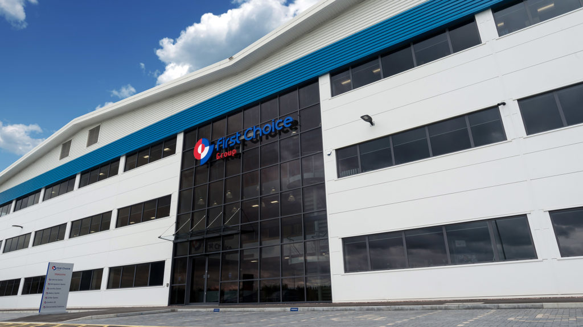
OUR MISSION
To consistently exceed customer expectations through unrivalled service, built on outstanding teamwork, responsiveness, parts availability and technical expertise, and supported by continual investment in innovation, training, technology and manufacturer partnerships.
The First Choice Group mission is what drives us as a business. This mission embraces the culture and ethos of the company, it is what motivates us to succeed every single day.
Supporting our mission are our Core Values – a set of six principles that direct the way we perform and fulfil our commitments as a team, to each other and to our customers. They are what we measure ourselves by as an organisation and offer a unique insight into the culture embedded into First Choice Group.
OUR VALUES

Safety
Demonstrating outstanding knowledge and awareness of all safety principles and promoting safety in the workplace to serve the best interests of all employees and visitors. This applies to the aims of the First Choice Training department which teaches our customers the aspect of safety on a daily basis, as well as the safety of OEM parts.

Integrity
Always open and honest during interactions with everyone in the First Choice Group community, showing empathy, morals and ethics while believing deeply in the company’s core values. Emphasis is placed on our customers who receive the upmost integrity from each and every member of our staff.

Innovation
Strives to create unique solutions which benefit the customer by thinking creatively and showing initiative which attracts opportunities to advance the company’s capabilities. Our innovations for customers span across our facilities, distribution hub automation, our digital platforms and our training courses.

Passion
Cares deeply about the company and strives to be the best, showing pride and willing to go the extra mile with a desire for shared success. Passion is a value that we always aim to share with our customers day in, day out, whether it’s on the phone, in training or during manufacturer visits.

Courage
Confident enough to take risks with a conviction that encourages others to do the same and bold enough to make decisions which challenge the status quo to attain the highest standards of achievement.

Community
Our culture, charitable collaboration and caring celebrations in the local communities sets us apart and brings us closer together.

Each and every member of staff is committed to ensuring these six core values remain at the forefront of everything we do, striving to continuously deliver a nationwide-leading, premium service for our customers and manufacturer partners.
VIP CORE VALUES CHARTER
This charter embraces the culture and ethos of the company, it is what motivates us all to succeed every day.
Supporting our mission are our Core Values, a set of six principles that direct the way we perform and fulfil our commitments as a team, to each other and to our customers and suppliers. They are what we measure ourselves by as an organisation and offer a unique insight into the culture embedded into First Choice Group.
First Choice recognizes six core values Safety, Passion, Community, Integrity, Courage & Innovation, and each team member is encouraged to work & live by these principles. Employees are always selected and evaluated based on their fit to these core values.
First Choice established the VIP Core Value Awards program as a way of recognising the best of the best and suitably acknowledging their achievements. This scheme allows all team members to nominate deserving colleagues based upon stories of their upholding of one or more core value.
As has become customary, bimonthly Winners get highlighted and acknowledged during the special VIP ceremony which is always hosted by our Managing Director

